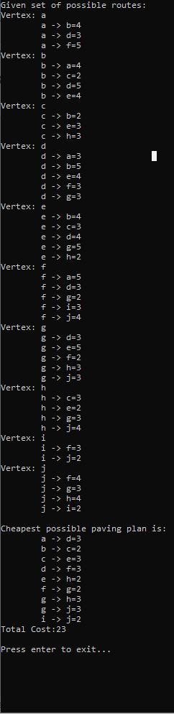



J

I

C

G

F

H

E

D

B

A